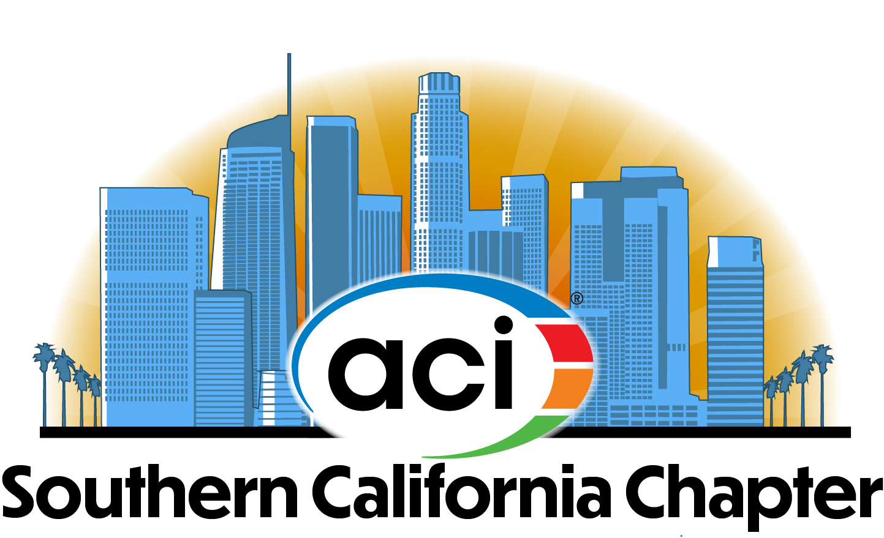
ACI SOUTHERN CALIFORNIA CHAPTER CONCRETE AWARDS
2021 CALL FOR ENTRIES

Purpose:
The ACI Southern California Chapter Concrete Awards includes eight potential awards to recognize outstanding achievements in various categories of concrete construction. In addition to the seven award categories for 2021, one distinguished project may receive the Charles J. Pankow, Jr. Award, which recognizes outstanding and innovative use of concrete in construction. This award was established by the Southern California Chapter in 1984 in honor of Charles J. Pankow, Jr. who served as the International President of ACI in 1980-1981 and was active in the Southern California Chapter since its founding. The award is made annually, if, in the judgment of the Awards Committee(s), a qualified project and contractor are nominated.

The citation on the original award presented to Charles Pankow on March 22, 1984 reads:
Special Award
Charles J. Pankow, Jr.
For Distinguished Service to the Concrete Industry as National ACI President, Director and TAC Member. One of the Founders of the Southern California Chapter, Innovative Engineer, and Builder Leader in Concrete Construction

Award Categories
- Low-Rise Buildings/Structures: Up to three stories residential (multi-family and houses), school, commercial, warehouse and industrial, etc.
- Mid-Rise Buildings/Structures: Four to fifteen stories
- High-Rise Buildings/Structures: More than fifteen stories
- Decorative: Decorative or architectural feature or element such as exterior or interior finishes, hardscapes, ornamentation, stained, stamped, or polished concrete, art installations, etc.
- Infrastructure: Bridges, site structures, water resource structures, marine structures, other structures, etc.
- Flatwork: Pavements, parking lots, runways, commercial/industrial floors, etc.
- Repair and Restoration: Overlays, rehabilitation, remodel, retrofitting, etc.

Charles J. Pankow, Jr. Award: One project of outstanding merit will be selected to receive the distinguished Charles J. Pankow Award

Project Criteria
All projects must:
- Be completed between October 2020 and September 2021. For buildings, project completion date is defined as the date on the certificate of occupancy.
- Utilized concrete as an architectural finish, structural element, or artwork
- Have informed and received consent from all members of the project team

Entry Criteria
All entries must include:
- Completed online entry form
- 500-word (or fewer) concrete description
- 300-word (or fewer) project description
- Minimum of six, maximum of 12 photographs featuring the concrete, construction, and finished project. Time lapse videos are also accepted in addition to the photographs.
- Indicate to whom award plaques should be given (company or individual person) and verify accurate spelling of names for award plaques

Judging Criteria
The ACISCC Concrete Awards Committee will judge the project submissions based on the following criteria:
- Architectural merit
- Engineering merit
- Creativity
- Innovative construction techniques or solutions
- Innovative use of materials
- Ingenuity
- Sustainability and resilience
- Functionality and end-use suitability

Presentation of awards will occur at the Annual Concrete Awards event hosted by ACI Southern California Chapter. We are excited to announce that this year’s event will be held on November 4, 2021 at SoFi Stadium. Thank you to our Platinum Sponsors below for supporting our 2021 Concrete Awards event.

Information gathered for the purpose of this awards program may be published in various media outlets (print, Internet, Social Media) for the purpose of highlighting concrete’s use in design and construction.

Deadline for Entries: MONDAY, SEPTEMBER 13, 2021

Sponsorship opportunities are available for our 2021 Event! For questions regarding the sponsorship or general questions about the ACISCC Concrete Awards program, please contact Heather Todak, by phone at (626)-696-4664 or by email at htodak@wje.com

